FaceID Function Details:

^{7th} Feb 2010
Tính sai:
Test case: WCal: from 9:00 to 18:00
Break: from 12:00 to 13:00 paid yes
Record: in 9:00 out 11:30 in 12:30 out 18:00

TotalHours:
Expected: 8.5 (do nghỉ trưa sớm hơn 30phút: 9 – 0.5 = 8.5hrs)
Actual: 8 (trừ đi 1 tiếng 11:30 – 12:30 trong khi 12:00 – 12:30 là giờ nghỉ có trả lương)

^{5th} Feb 2010
Các biến số mới trong bảng Working Calendar để dễ tính toán.

Grace forward to entry: minutes, number
Ví dụ: 30 phút, giờ bắt đầu làm 8h.
- Check-in trước giờ làm việc trong khoảng 30 phút (7h30 – 8h00) thì tính như check-in đúng 8h (trong db vẫn lưu chính xác thời điểm check-in).
- Checkin trước giờ làm việc hơn 30 phút (trước 7h30) thì tính là overtime. Ví dụ: check-in 7h15 -> 45 phút overtime.
- Exception: In 7h15, Out 7h45, In 7h55 -> 30ph overtime

Grace back to exit: minutes, number
Ví dụ: 30 phút, giờ nghỉ làm 18h
- Check-out sau giờ nghỉ làm trong khoảng 30 phút (18h00 – 18h30) thì tính như check-out đúng 18h
- Check-out sau giờ nghỉ làm hơn 30 phút (18h30 trở đi) thì tính overtime. Ví dụ: check-out 19h15 -> 1h15 phút overtime
- Exception: Out 18h15, In 18h20, Out 19h20 -> 1h overtime

Earliest check-in allowed: minutes, number
Ví dụ: 60 phút, giờ làm 8h.
- Check-in trước giờ làm hơn 60 phút (trước 7h) sẽ ko đc tính (tạm thời vẫn ghi vào db)

Lastest check-out allowed:
Ví dụ: 240 phút, giờ nghỉ làm 18h
- Check-out sau giờ làm hơn 240 phút (sau 22h) sẽ ko đc tính (tạm thời vẫn ghi vào db)

Const: lastest >= graceback, earliest >= graceforward

Test case:
WCal: 8h – 18h, no breaks, grace forward 30ph, grace backward 30ph, earliest 60ph, latest 240ph

Records: 1/1/2010 8h, 18h -> total hours = 10
Records: 2/1/2010 7h45, 18h15 -> total hours = 10
Records: 3/1/2010 7h15, 18h -> total hours = 10h45ph
Records: 4/1/2010 6h, 18h -> total hours = 0, missing In
Records 5/1/2010 12h, 23h -> total hours = 0, missing Out

4th Feb 2010
Working Day: from (WorkFrom – timeBound) to (nextDay.WorkFrom – timeBound)

DateTime GetWorkingDayByAttendanceRecord(AttRecord attRecord)
{
WorkingCalendar wCal = .GetWorkingCalendarByAtt();

DateTime wFrom = new DateTime(attRecord.Year, attRecord.Month, attRecord.Day, wCal.Hour, wCal.Min, wCal.Sec).AddMin(-timeBound);

if(attRecord.Time > wFrom)
return wFrom;
else
{
if( Is1stday() )
return wFrom;
else
return wFrom.AddDay(-1);
}
}

What’s left?
- Import Employee from MYOB file (✓)
- DB Backup (automate and manual) (✓)
- User login & User access management & Backdoor access (✓)
- Reprocess (doing)
- Pay period and Attendance log error checking before exporting payroll (doing)
- Log of changing (attendance log)
- Configuration:
  - Option to show/hide chart in Attendance Report
  - Default directory for exporting
  - Time bound value
- GUI: Icon + Metaphor (✓)
- Installation + Installation Guide
- User Manual (doing)

2nd Feb 2010
Attendance Report:
- Report Sort: By employee then date (current: by date then employee) (✓)

Attendance Log:
- Alert Mistakes: if (number of check in) > (number of check out) and current datetime > wday.workTo

Employee Number | Employee Name | Date | Attendance Details | Total Hours | Note
1 | Vo, Ngoc Anh | 1/1/2010 | In: 09:00:15 | X
1 | Vo, Ngoc Anh | 1/1/2010 | Out:  10:30:12 | X
1 | Vo, Ngoc Anh | 1/1/2010 | In: 11:34:23 | X
1 | Vo, Ngoc Anh | 1/1/2010 | Out: 13:40:23 | X
1 | Vo, Ngoc Anh | 1/1/2010 | In: 15:31:42 | X
1 | Vo, Ngoc Anh | 1/1/2010 | Out: | X
Users can double click (or right click – choose add) on the highlighted column to open “Add new attendance record” form”. Employee number, employee name and date should be filled automatically and are read-only.

Payroll Export:
- Prevent users from exporting payroll as long as there’re mistakes in Attendance Log. Users should be informed about the mistake (Employee Number, Employee Name, Date)

- Prevent users from exporting payroll which is unmatched employee’s pay period.
Ex: Pay period 4 days, starts from 1/1/2010
Only payroll export for (1/1/2010 – 4/1/2010, 5/1/2010 – 8/1/2010…) should be allowed

(1/1/2010 – 3/1/2010, 1/1/1010 – 5/1/2010…) must be blocked and a message should be displayed tell users what’s wrong and how to fix it?

This will lead to complexity as there’re different pay periods. Users should be provided options to choose the pay period before exporting.

Note: PayPeriodID is stored in AttReport table.

Reprocess:
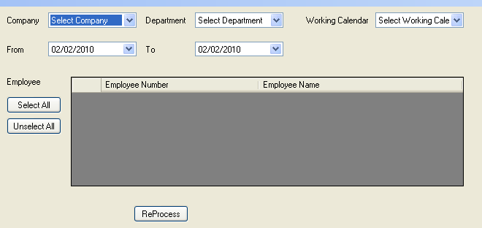

cbxCompany:
- Has an “All” item (text = “All” value = “-1”)
- Default: selectedText = “Select Company”, selectedValue = “0”
- Bind all companies

cbxDepartment:
- Has an “All” item (text = “All” value = “-1”)
- Default: enabled = false, selectedText = “Select Department”, selectedValue = “0”
- Enabled = selectedCompanyID > 0
- Bind all departments of selected company

cbxWorkingCalendar:
- Has an “All” item (text = “All” value = “-1”)
- Default: selectedText = “Select Working Calendar”, selectedValue = “0”
- Bind all working calendars

dtpReprocessFrom:
- Default: first day of current month

dtpReprocessTo:
- Default: today

dgvEmployee:
- Bind all employees that are related to selected company, selected department, selected working calendar.
- Default: None rows are selected

btnSelectAll:
- Select all employees in dgvEmployee

btnUnselectedAll
- Unselect all employees in dgvEmployee

btnReprocess:
- Show frmReprocessStatus
- Re-calculate attendance records/reports for all selected employees during selected period.

Validation:
- dtpReprocessFrom <= dtpReprocessTo
- (companyID > 0 && deparmentID != 0) || (companyID == -1 && deparmentID == -1)
- workingCalendarID != 0
- employeeList.Count > 0

30th Jan 2010
PerfomanceTest: Add then Calculate Att Records
Add 100 (25 emp 1 day)
00:05:093 - 00:03:359 - 00:03:937

Add 200 (50 emp 1 day)
00:02:953 - 00:03:703 - 00:04:140

Add 500 (100 emp 1 day)
00:09:187 - 00:09:046 - 00:10:968

Add 1000 (250 emp 1 day)
00:13:593 - 00:17:875 - 00:21:078

Add 2000 (500 emp 1 day)
00:28:500 - 00:38:265 - 00:45:015

Add 5000 (250 emp 1 week)
01:16:140 - 01:01:312 - 01:34:609

Add 10000 (500 emp 1 week)
02:48:296 - 04:27:578 - 05:52:421
02:36:125 - 03:56:761

Add 20000 (500 emp 2 weeks)
05:28:937 - 10:01:484 - 19:28:734

Add 50000 (500 emp 1 month)
40:07:155

Add 150000 (max)

30th Jan 2010
Attendance Log & Report:
1. Employee Name format: Last, First (ex: Vo, Ngoc Anh)

2. Attendance bugs:
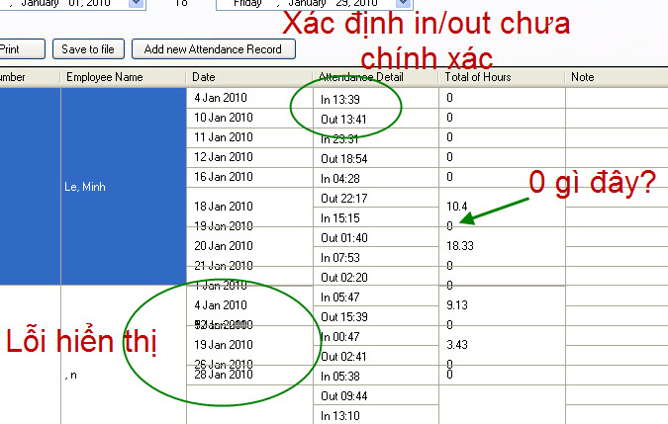
In/Out assigned incorrectly: 1 working day must starts with In not Out

3. Attendance Report:
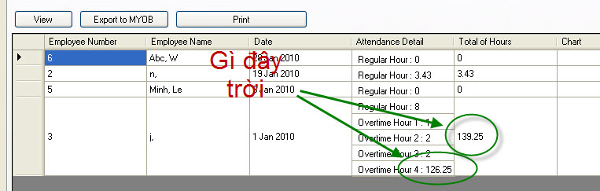

29th Jan 2010
AttendanceLog
- Attendance details must be in format: In/Out: hh:mm:ss

Attendance Report:
- Chart: Examples:
4 hrs
8 hrs
3 hrs
GRAY: Hours to work
green: HOURS Worked
REd: Hours OVERTIME

26th Jan 2010
Payroll Export
From 21th Jan 2010 To 27th Jan 2010 (1 Week)
Payroll Number | Employee Number | Employee Name | Job Description | Regular Hours | Overtime Hours | Total Hours | Total Hours (with rate)
1 | 1 | Vo, Ngoc Anh | Developer | 40 | 2 x 150%  1 x 200% | 43 | 45
2 | 2 | Le, Minh | Developver | 40 | 1 x 250% | 41 | 42.5
Total |  |  |  | 80 | 4 (not 7.5) | 44 | 47.5

Order by payroll number ASC

24th Jan 2010
ucEmployeeForm
- Add an option in cbxCompany and cbxDepartment allows user to view all undistributed employees (employee that has not been assigned to any company, department)
- Employee Print format:
Employee No | Employee Name | Department | Job Description | Hired Date

19th Jan 2010
Add/Update/Delete Attendance function:
Attendance Log Form:
- All Companies are displayed in cbxCompany by default (with an “All companies” option that allows users to view employees of every companies). When “All companies” is selected, cbxDepartment is disabled. “All companies” is selected by default.
- All Departments of the current selected company are displayed in cbxDepartment (with an “All departments” option that allows users to view every employees of the selected company). “All departments” is selected by default.
- dtpAttendanceFrom: The first day of the current month is selected by default.
- dtpAttendanceTo: Current day is selected by default.
- No Att record is displayed in dgvAttendanceLog until user clicks on btnView
- Employees’ Name should be in Last Name, First Name format
- (Complicated)Attendance Detail: Group by working day, an employee can check in and out many times in a working day.
- In: TimeIn1
- Out: TimOut1
- In: TimeIn2
- Out: TimeOut2
- …
Ex
- In: 09:00
- Out: 12:00
- In: 13:00
- Out: 18:00
- …
A working day could be in 2 different days (ex: employee works from 9PM to 6AM, according to his working calendar).
Terminal does not record which log is check in and which one is check out, so it must be calculated by the software. Ex: first log is first in, last log is last out, second and third are for break1… If number of in != number of out -> error.

- (Complicated)Total Hours: = (Last Out – First In) – (Total breaks)
Ex: (18 – 9) – (13 - 12) = 8 hours
- btnCollectData, btnPrint, btnSaveToFile: leave them for now
- btnAdd: show frmAddUpdateAttRecord

Add Attendance Record Form:
- nudEmployeeNumber: no employee is selected by default.
- txtEmployeeName: can be used to search for an employee (by first name and last name)
- date and time: current datetime
- btnUpdate is hidden
- Must prevent duplicate record (same employee, same datetime)
Update Attendance Record Form:
- nudEmployeeNumber: load updating employee Number, is not editable.
- txtEmployeeName: load updating employee Name, is not editable
- date and time: attendance record’s datetime
- btnAdd is hidden
- Must prevent duplicate record (same employee, same datetime)

15th Jan 2010
Add/Update/Delete Employee function:
Employee Form:
- All Companies are displayed in cbCompany by default (with an “All companies” option that allows users to view employees of every companies). When “All companies” is selected, cbDepartment is disabled. “All companies” is selected by default.
- All Departments of the current selected company are displayed in cbDepartment (with an “All departments” option that allows users to view every employees of the selected company). “All departments” is selected by default.
- No employees are displayed in dgvEmpl until user clicks on “View” button
- Employees’ Name should be in “Last Name, First Name” format (ex: Vo, Ngoc Anh)
- Terminal Register should be separated by a comma (ex: T1, T2)

Add New Employee:
- User clicks on Add New Employee to open form frmAddUpdateEmployee to add a new employee
- Update button is hidden
- User clicks on Add to add a new employee, Cancel to go back
- All Companies are displayed in cbxCompanyby default (with no “All companies”). The first company is selected by default.
- All Departments of the current selected company are displayed in cbxDepartment (with no “All departments”). The first departments is selected by default.
- All Working Calendars are displayed in cbxWorkingCalendar
- Employee Number is calculated automatically, not editable, and must be the smallest available number. (ex: there’re employee number 1, 2, 4, 10 in database, then the chosen number is 3) – Check on Delete Employee for more detail.
- Payroll Number is calculated automatically, not editable, and is unique.
- Every field must be entered.
- Left date >= Joined date >= birthday
- Employee may not register on any terminal
- User click on Change to register/unregister employee on terminals
- Error and Succeed message must be shown.

Register/Unregister employee on terminals:
- User clicks on Change to open frmTerminalRegister
- All terminals are displayed in lbxAvailTerminal
- User can select many Avail Terminals and click on add to register employee.
- Terminal Registered will be displayed in lbxRegTerminal
- Use can select many Reg Terminals and click on remove to unregister employee.
- User click on Finish to submit changes, cancel to go back without saving changes.
- Terminal Registered will be displayed in lbxTerminal in frmAddUpdateEmployee

Update Employee
- Similar to Add Employee
- User right-clicks and Employee and choose Edit to open form frmAddUpdateEmployee to update that employee
- Add button is hidden, Update button is visible.
- Employee Number and Payroll Number are not editable
- Working Calendar is not editable

Delete Employee
- User right-clicks and Employee and choose Delete to delete that employee
- Confirm message and succeed message must be displayed.
- Deleted employee will NOT be removed from database, only their Active property will be changed to False. His attendance records should also remain.
- Only after an employee is inactivated, his Employee number will become available and can be used by another Employee.
- An Employee number can only be used by one active Employee at a moment.

Future functions:
- After an employee is registered/unregistered on terminals, some requests will be sent to terminals to add/remove that employee’s data.
- Working Calendar can be changed, but changing time must be recorded.

14th Jan 2010
Add/Update/Delete Terminal function:
- All Terminals are display in DataGridView by default
- Update and Cancel button are not visible by default
- Terminals can be sorted by Name or IP Address by clicking on headers
- User can right-click on a Terminal and choose to Edit/Delete
- A Terminal status is Avail (if can be connected) or NA (if cannot be connected). Status checking should be done in another thread to improve performance.
- Add Terminal:
  - User enters Name and IP Address then click on Add to add a new Terminal
  - Two terminals must have different name and IP Address.
  - Name and IP Address must not be empty
  - IP Address must be valid
  - Error message and succeed message must be shown.
  - After user adds successfully, all text fields will be cleared, Grid will be updated
- Update Terminal
  - User right-click on a Terminal and choose Edit to start editing a Terminal
  - Add button will be hidden, Update and Cancel button will be visible
  - Two terminals must have different name and IP Address.
  - Name and IP Address must not be empty
  - IP Address must be valid
  - Error message and succeed message must be shown.
  - After user updates successfully or clicks on Cancel button, Add button will be visible, Update and Cancel button will be hidden, all text fields will be cleared, Grid will be updated
- Delete Terminal
  - User right-click on a Terminal and choose Delete to delete a terminal
  - A confirm message must be displayed
  - A terminal that have employees registered on, can still be deleted, all employees registered on that terminal should remain (which terminalID = null)

11th Jan 2010
Add/Update/Delete companies function:
- All companies are displayed in DataGridView
- Update button is not visible by default
- Companies can be sorted by name by clicking on Name header
- User can click on Edit to Update an existing company
  - If user is adding a new company, a confirm message should be displayed
  - Updating state:
    - Add button is hidden
    - Update button becomes visible
    - Chosen company’s info is loaded to the form
    - User clicks on Update to update company
- User can click on Delete to Delete an existing company
  - A confirm message must be displayed
  - If company is in used (has departments, employees), then it must not be deleted and a message will be displayed
  - Otherwise, it will be removed and a message will be displayed
- User click on Add to Add a new company
- Company name must be unique and need to be checked when adding or updating

Add/Update/Delete Departments function:
- Similar to Add/Update/Delete companies function
- Right-click on an item to open menu (Edit, Delete)
- A department name must be unique within a company
- One department may have many sub-departments

Database:
Company[CompanyName] PK(CompanyName)
Deparment[DepartmentName, CompanyID, SupDeparmentID] PK(DepartmentName, CompanyID)

Coding:
An interface (iDatabaseAccess or whatever) will be use for database accessing

